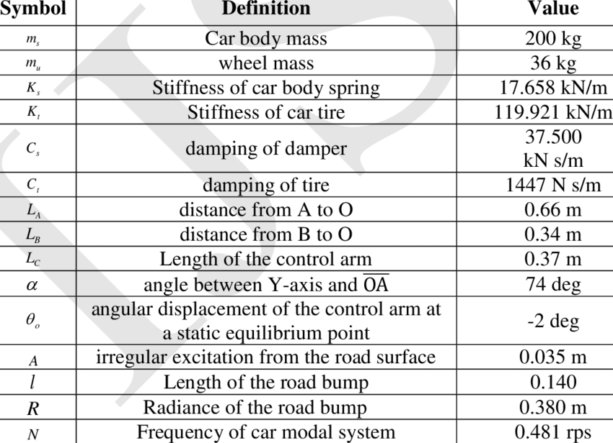

¼ https://www.researchgate.net/publication/320487516_Simulation_of_Nonlinear_Quarter_Car_Suspension_System_with_and_without_Tire_Damping#pf4

Half Car

https://www.researchgate.net/figure/Parameters-for-half-car-model_tbl2_309585588